Figure 1. Distribution of total scores on the Croatian version of the MWQ

Figure 2. Estimated normalized parameters of the CFA model
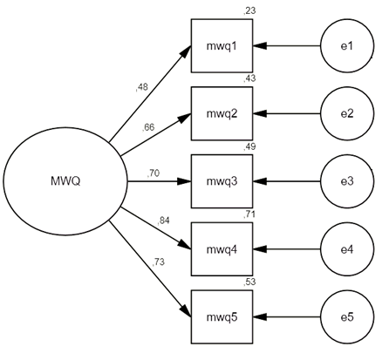
χ² = 11.19, df = 4, p = .025, χ²/df = 2.798, CFI = .991, RMSEA = .063, SRMR = .0261

